DATA ANALYTICS FOR DHL LOGISTICS FACILITIES



**Team ID :** PNT2022TMID19446

**Team Members**

1. VIKRAM S
2. SUMESH S
3. VIGNESH N
4. VIMALKUMAR M

**Industry Mentor :** RAKESH MISKIN

**Faculty Mentor :** SREEMATHY

# TABLE OF CONTENTS

|  |  |  |
| --- | --- | --- |
| **S. No.** | **Title** | **Page No.** |
| (i) | Abstract | 4 |
| **1** | **INTRODUCTION** |  |
|  | 1.1 Project Overview | 5 |
|  | 1.2 Purpose | 6 |
| **2** | **LITERATURE SURVEY** |  |
|  | 2.1 Existing Problem | 7 |
|  | 2.2 References | 7 |
|  | 2.3 Problem Statement Definition | 8 |
| **3** | **IDEATION & PROPOSED SOLUTION** |  |
|  | 3.1 Empathy Map Canvas | 10 |
|  | 3.2 Ideation & Brainstorming | 10 |
|  | 3.3 Proposed Solution | 11 |
|  | 3.4 Problem Solution Fit | 12 |
| **4** | **REQUIREMENT ANALYSIS** |  |
|  | 4.1 Functional Requirement | 13 |
|  | 4.2 Non-Functional Requirement | 13 |
| **5** | **PROJECT DESIGN** |  |
|  | 5.1 Data Flow Diagram | 14 |
|  | 5.2 Solution & Technical Architecture | 14 |
|  | 5.3 User Stories | 15 |
| **6** | **PROJECT PLANNING & SCHEDULING** |  |
|  | 6.1 Sprint Planning & Estimation | 16 |
|  | 6.2 Sprint Delivery Schedule | 16 |
|  | 6.3 Reports from JIRA | 17 |

|  |  |  |
| --- | --- | --- |
| 7 | ADVANTAGES & DISADVANTAGES | 18 |
| 8 | CONCLUSION | 21 |
| 9 | FUTURE SCOPE | 22 |
| 10 | APPENDIX | 24 |

**ABSTRACT**

DHL Logistics Facilities using Data Analytics provides customers in many industry sectors with logistics services along the entire supply chain from planning, sourcing, production, storage and delivery to return logistics and value-added services. Since its arrival in the first edition of the DHL Logistics Trend Radar in 2013, Big Data Analytics has developed and today is increasingly becoming part of the de-facto operating model for the logistics industry. Surging demand for personalised and context-based services has driven development of artificial intelligence (AI) and machine learning applications which, in turn, have upped the need for larger datasets in the industry for better results.

Additionally, the rapid migration of enterprise data storage from traditional data centres to the cloud has provided more flexibility in effectively scaling storage and processing power for all collected data. The need for visibility and prediction is ever-more pressing. COVID-19 has caused unprecedented uncertainty in supply chains globally, affecting how goods are moved and altering consumer demand and behaviour.

Big data analytics holds the key to uncovering hidden issues across entire supply chains and surfacing trends that are not so obvious. As companies around the world recover, demand is growing for promising features of data analytics, such as mitigating disaster risks, simulating operations, and improving customer service.

# INTRODUCTION

* 1. **PROJECT OVERVIEW:**

DHL Logistics Facilities is concerned with getting the products and services where they are needed and when they are desired with the help of Data Analytics. It is difficult to accomplish any marketing or manufacturing without logistical support. It involves the integration of information, transportation, inventory, warehousing, material handling, and packaging. The operating responsibility of logistics is the geographical repositioning of raw materials, work in process, and finished inventories where required at the lowest cost possible. Logistics has been practised for ages since organised activity began. Without logistics support no activity can be performed to meet defined goals. The current challenge is to perform logistics scientifically in order to optimise benefits to the organisation. Logistics is a planning function of management. Logistics function is concerned with taking products and services where they are needed and when they are needed. Logistics is being transformed through the power of data-driven insights. Thanks to the vast degree of digital transformation and the Internet of Things, unprecedented amounts of data can be captured from various supply chain sources. Capitalising on its value offers massive potential to increase operational efficiency, improve customer experience, reduce risk, and create new business models.

Real-time process optimization and simulation are becoming increasingly important tools for supply chain management. As worldwide complexity grows, the ability to run global supply chains at peak efficiency becomes more and more challenging. Warehouse operators and supply chain managers can make better decisions with granular visibility of processes like order management, and inventory levels and resource utilisation become transparent in live dashboards. We understand that dynamic technology markets demand dynamic solutions. So we seek strong partnerships with every customer, envisaging and creating the connections to achieve business success. You can rely on our unrivalled global reach, experience and engagement. We’ll help you to imagine and enable new approaches and solutions. Together we will push the pace of change. And always we will enrich your experience with our industry-leading logistics services.

# PURPOSE:

The purpose of this study is identifying the services marketing mix (7Ps-product/service, place, promotion, price, people, processes and physical evidence) decisions of a logistics company. The significance of services marketing mix on creating a logistics services brand has received little attention in the literature. In this paper, the case of a global brand, DHL Logistics is presented. Case study was conducted by using secondary data obtained from DHL. Logistics’ reports and by conducting semi constructed interviews with DHL Logistics’ executives and employees. Due to the reputation and operations of the company, this framework will act as a guideline for the other companies. The marketing mix decisions made by DHL Logistics affect both B2B and B2C customers’ brand perceptions and enhance the brand equity of DHL Logistics.

# LITERATURE SURVEY

* 1. **EXISTING PROBLEM:**

DHL is a global expertise in express, air and ocean freight, overland transport and logistics solutions; DHL combines worldwide coverage with an in-depth understanding of local markets. DHL India has an outstanding reputation in the market for providing a reliable, fast and easy-to-use service. DHL offers Highly trained and professional staff, committed to being responsive to all customers' needs Customer Service Agents, available round-the-clock, 365 days of the year, to serve customers whenever and wherever they need them. Electronic Pre-clearance of shipments through Customs Five international gateways providing direct-to-air networks and faster sorting of inbound and outbound shipments.

DHL India is a proven facilitator of trade, across the globe. His strength lies in our global network and the know-how of our people. Backed by strategic alliances with world-class partners and the innovative use of technology, they strive to continuously improve the quality of our service. Our services range from fast, responsive and cost-effective express deliveries toe-commerce fulfilment and intelligent logistics solutions. DHL Core Services consist of door-to-door air express delivery of documents and parcels of all sizes (and weight), both into and out of the country. Other value-added services are a. Kitting/Pre-Assembling Kitting is the addition of items such as accessories and batteries to the product pack.

# REFERENCES:

* + - Aaker, D. A. (2001), Strategic market management. John Wiley & Sons, Inc. Courier Westford, United States of America.
    - Ahmed, P.K &Rafiq, M. (2003), Internal market issues and challenges, European Journal of Marketing, Vol. 37 No. 9, pp. 1177-1186.
    - Bennett, R & Thiele, S.R. (2004), Customer satisfaction should not be the only goal, Journal of Services Marketing, Vol. 18 No. 7, pp. 514-523.
    - Bergman, B & Klefsjo, B. (2010), Quality from customer needs to customer satisfaction, Studentlitteratur AB, Lund, Sweden.
    - Berry, L.L & Parasuraman, A. (1991), Marketing to existing customers, in marketing service: competing trough quality, The Free Press, New York.
    - Doyle, P & Wong, V. (1998), Marketing and competitive performance: an empirical study, European Journal of Marketing, Vol. 32 No. 516, pp. 514-535.
    - Gerhardt, P.L. (2002), A paper presented in partial fulfilment of the requirements of OM 814 marketing strategy and practice, Journal of Service Marketing, Vol. 20 No. 8, pp. 150-160.
    - Gronroos,C. (2000), Service Management and Marketing: A Customer Relationship Management Approach, Wiley, Chichester.
    - Hedging , T., Knudtzen, C. F. & Bjerre, M. (2008), Brand Management - Research, Theory and Practice. u.o.:Routledge.
    - Hyder, A. S & Abraha, D. (2003), Strategic alliances in Eastern and Central Europe, Pergamon, An Imprint of Elsevier Science. United States of America

# PROBLEM STATEMENT DEFINITION:

In today's world, the difficulty arose in the industry of Logistics from the fragmentation and inconsistency. We can’t create a centralised control over the Logistics industry due to many departments/sectors involved such as managers, manufacturers, stride keepers and end users.

# IDEATION AND PROPOSED SOLUTION

* 1. **EMPATHY MAP CANVAS:**

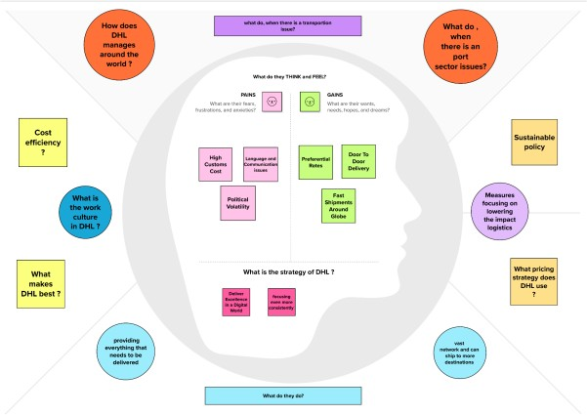

*Fig.1: Empathy Map Canvas*

# IDEATION & BRAINSTORMING

Step-1: Team Gathering, Collaboration and Select the Problem Statement

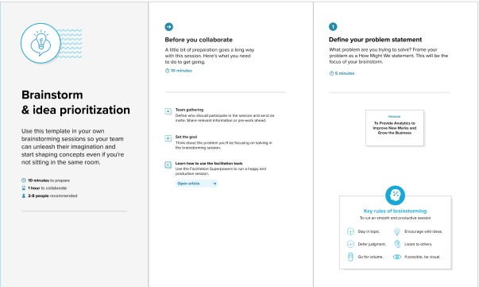

*Fig.2: Brainstorming*

Step-2: Brainstorm, Idea Listing and Grouping

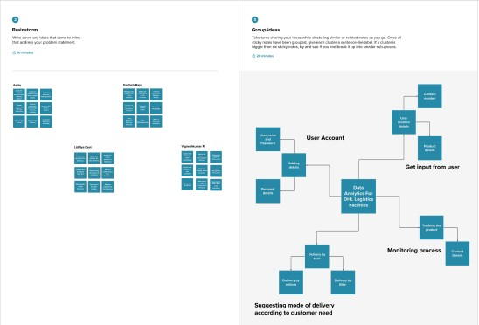

*Fig.3: Idea Listing*

Step-3: Idea Prioritisation

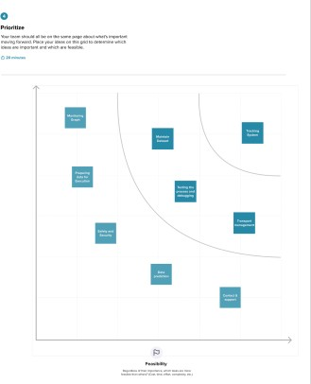

*Fig.4: Prioritisation*

# PROPOSED SOLUTION:

|  |  |  |
| --- | --- | --- |
| **S.No.** | **Parameter** | **Description** |
| 7 | Problem Statement (Problem to be solved) | In today's world, the difficulty arose in the industry of Logistics from the fragmentation and inconsistency. We can’t create a centralised control over the Logistics industry due to many departments/sectors involved such as managers, manufacturers, stride keepers and end users. |
|  | Idea / Solution description | With the aim of organising and managing those ideas for improvement or development, idea management software structures the process of gathering and developing ideas around business focus areas, such as product development, regular processes, customer feedback, market trends, and competitive insights. With the aim of organising and managing those ideas for improvement or development, idea management software structures the process of gathering and developing ideas around business focus areas, such as product development, regular processes, customer feedback, market trends, and competitive insights. |
|  | Novelty / Uniqueness | DHL, a thought leader in the logistics sector, strategically invests in trend analysis and the creation of solutions. The workplace, working culture, and workforce are all changing. |
|  | Social Impact / Customer Satisfaction | Delivering client satisfaction while making a profit is marketing. In this study, customer relationship management (CRM) is identified. It's impossible to overstate the value of a great customer experience. |

|  |  |  |
| --- | --- | --- |
|  | Business Model (Revenue Model) | A business model helps a business to build its business by  analysing what they are going to sell and how are they going to promote  it. It also helps it analyse what are the expenses it is going to incur and how is it going to make a profit. |
|  | Scalability of the Solution | A flexible system that can adapt to shifting customer needs and service standards. Whatever the size or shape of your business, you will gain. |

* 1. **PROBLEM SOLUTION FIT**

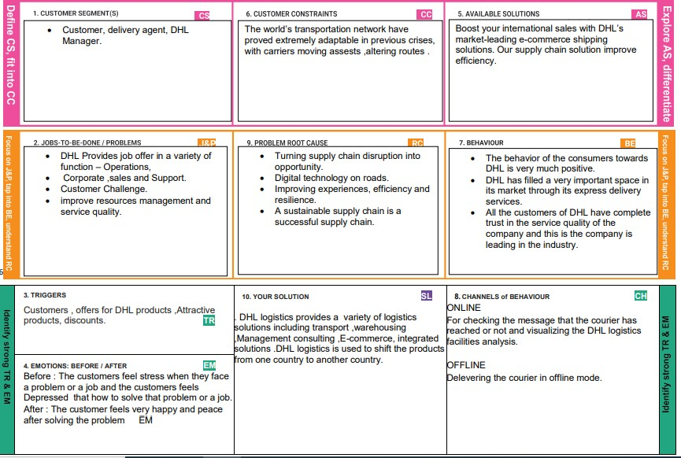

*Fig.5: Solution Fit*

# REQUIREMENT ANALYSIS

* 1. **FUNCTIONAL REQUIREMENTS:**

|  |  |  |
| --- | --- | --- |
| **FR**  **No.** | **Functional Requirement (Epic)** | **Sub Requirement (Story / Sub-Task)** |
| FR-1 | User Registration | Registration through any google account or social media account |
| FR-2 | User Confirmation | Confirmation via Email Confirmation via OTP |
| FR-3 | Dashboard | The collected data are found in visualized format and the prior data is analysed |
| FR-4 | Dataset | The DHL FACILITIES record are collected and consolidated as dataset. |
| FR-5 | Report Generator | The periodic reports of Logistics are reported. |
| FR-6 | Exploration | The data exploration on available dataset. |

# NON-FUNCTIONAL REQUIREMENTS:

|  |  |  |
| --- | --- | --- |
| **NFR**  **No.** | **Non-Functional Requirement** | **Description** |
| NFR-1 | **Usability** | No prior experience required to use the dashboard.  People with basic understanding can use  the system. |
| NFR-2 | **Security** | Only registered user can use this application. |
| NFR-3 | **Reliability** | The Analytics system ensures the reliability. |
| NFR-4 | **Performance** | Gets updated regularly to improve the performance of the application. |
| NFR-5 | **Availability** | The availability of dataset must be constrained for accurate data. |
| NFR-6 | **Scalability** | Any kind of data can be explored and the system is  quite expandable. |

* 1. **PROJECT DESIGN**

# DATA FLOW DIAGRAM:

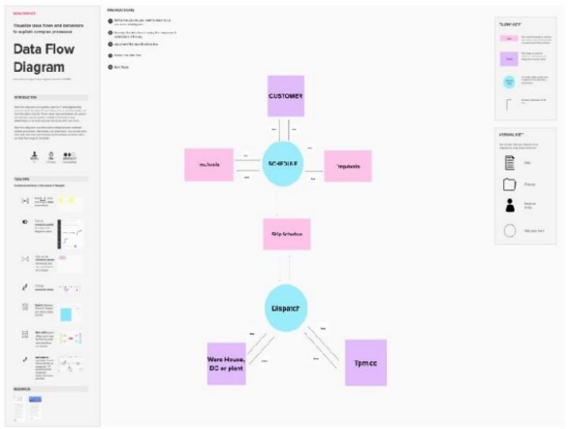

*Fig.6: Data Flow diagram*

# SOLUTION & TECHNICAL ARCHITECTURE:

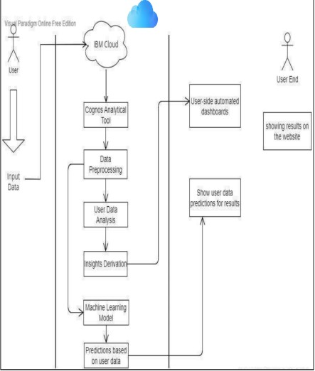

*Fig.7: Technical Architecture*

# USER STORIES:

|  |  |  |  |  |  |
| --- | --- | --- | --- | --- | --- |
| **Functional** | **User** | **User Story / Task** | **Story** | **Priority** | **Team Members** |
| **Requirem** | **Story** |  | **Points** |  |  |
| **ent (Epic)** | **Numb** |  |  |  |  |
|  | **er** |  |  |  |  |
| Login | USN- 1 | As a user, I can register & log into the application by entering email & password | 10 | High | Karthick Raja N |
| Verify | USN- 2 | As a user, I can verify the email with given otp and check for correct subscription access | 10 | High | Vignesh Kumar R |
| Collect data | USN- 3 | As an admin I can define questions & goals then collect data & provide the dataset in IBM Cognos analytics | 10 | Low | Lidhiya Devi S |
| Prepare | USN- | As an admin I can | 10 | Mediu | Ashiq |
| and | 4 | prepare, explore & |  | m |  |
| Explore |  | present the dataset in |  |  |  |
|  |  | IBM Cognos analytics |  |  |  |
| Analyze | USN- 5 | As an admin, I will analyze the given dataset (Data pre-processing) | 10 | High | Karthick Raja N |
| Predict | USN- 6 | As an admin, I will predict the length of stay (Prediction) | 10 | High | Karthick Raja N |
| Visualizati on | USN- 7 | As a user, I can select the visualization type like  Report, Dashboard and story (Creating  visualization) | 7 | Mediu m | Vignesh Kumar R |
| Dashboar | USN- | As a user, I can upload | 8 | High | Lidhiya Devi S |
| d | 8 | the datasets to the |  |  |  |
|  |  | dashboard and view |  |  |  |
|  |  | visualizations |  |  |  |
| Communi | USN- | As an admin, I can | 5 | Low | Karthick Raja N |
| cate | 9 | communicate to the client |  |  |  |
|  |  | for user queries and |  |  |  |
|  |  | visualize the best |  |  |  |
|  |  | dashboards in any |  |  |  |
|  |  | platform as a user |  |  |  |
|  |  | expected |  |  |  |

* 1. **PROJECT PLANNING & SCHEDULING**

# SPRINT PLANNING & ESTIMATION:

|  |  |  |
| --- | --- | --- |
| **Milestones** | **Tasks** | **Submission Date** |
| Milestone-1 | Collection of data from Kaggle | 17 Sept 2022 |
| Milestone-2 | Uploading the dataset on the IBM Cognos Tool | 17 Sept 2022 |
| Milestone-3 | Exploration and Visualization of data | 21 Oct 2022 |
| Milestone-4 | Creating Interactive dashboards | 27 Oct 2022 |
| Milestone-5 | Display the insights in the dashboard | 27 Oct 2022 |
| Milestone-6 | Prepare a standardised dataset and using the data required with the help of python program | 4 Nov 2022 |
| Milestone-7 | Usage of various algorithms to obtain the desired result with more accuracy using Google COLAB | 9 Nov 2022 |
| Milestone-8 | Display them in the required format | 16 Nov 2022 |
| Milestone-9 | Deploying in the Github | 16 Nov 2022 |

* 1. **SPRINT DELIVERY PLAN:**

|  |  |  |  |  |  |  |
| --- | --- | --- | --- | --- | --- | --- |
| **Sprint** | **Total Story Points** | **Duration** | **Sprint Start Date** | **Sprint End Date (Planne d)** | **Story Points Completed (as on Planned End Date)** | **Sprint Release Date (Actual)** |
| Sprint-1 | 20 | 6 Days | 24 Oct  2022 | 29 Oct  2022 | 20 | 29 Oct  2022 |
| Sprint-2 | 20 | 6 Days | 31 Oct  2022 | 05 Nov  2022 | 20 | 05 Nov  2022 |
| Sprint-3 | 20 | 6 Days | 07 Nov  2022 | 12 Nov  2022 | 20 | 12 Nov  2022 |
| Sprint-4 | 20 | 6 Days | 14 Nov  2022 | 19 Nov  2022 | 20 | 19 Nov  2022 |

𝐴𝑉 = **Sprint Duration / Velocity = 20/6 = 3.33**

# REPORTS FROM JIRA:

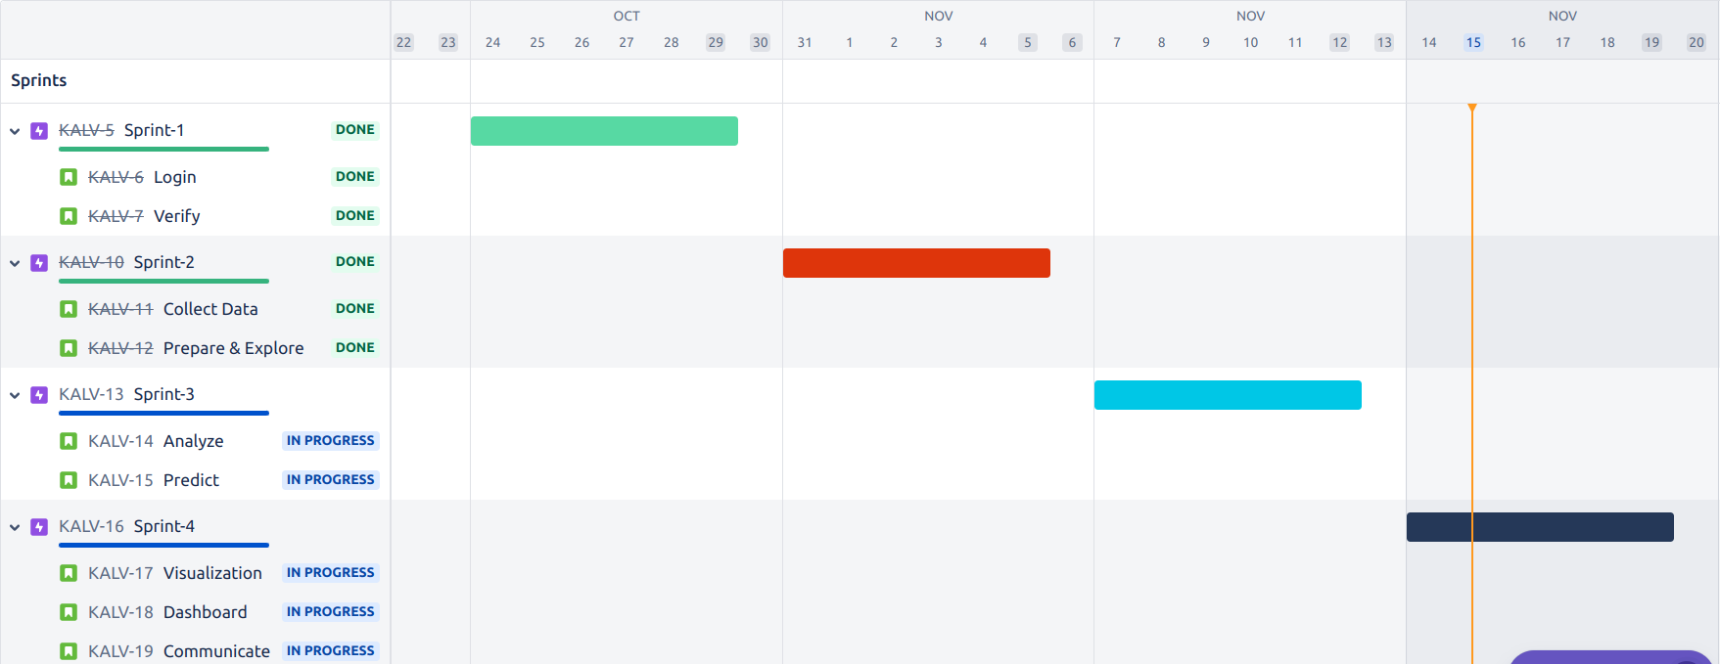

*Fig.8: JIRA Report*

# ADVANTAGES & DISADVANTAGES

**ADVANTAGES:**

# Unlocking key values

First of all, Data Visualization ensures that key values can be unlocked from massive sets of data. Large amounts of data in particular can be overwhelming and difficult to wrap our head around. Data Visualization helps with this by making the key values of the data clear and easily visible. This makes it easy to understand and interpret for everyone in the company.

# Identify patterns

Second, Data Visualization unlocks other previously invisible patterns. These other emergent properties in the data can formulate new valuable insights, which could not have been discovered before. Visualization allows business users to recognize relationships and patterns between the data, and also gives it greater meaning. By exploring these patterns, users can focus on specific areas that need attention in the data, to determine the importance of these areas to move their business forward.

# Easy to understand

The aim is to tell a good story by translating the data into a form that would be easy to understand for everyone. Eventually useful information would be highlighted and the noise would thus be eliminated from the data.

# More attractive and user-engaged

This attractiveness is achieved by using visually appealing ways of presenting data and adhering to design best practices. Next-level visualizations present data in a very sensible way by using the most appropriate chart and formatting options. In addition, elegant transitions facilitate an attractive and smooth way of moving between different points in the storyline of a visualization. This will increase a user's engagement with the visualization, thus facilitating easy and quick interpretation and understanding. As a result, the message resonates strongly with the

audience.

However, it is not as simple as taking the data and placing them in a graph and making it look better. It's an act of balance between the form and a function. A plain graph can be boring to catch the attention or make a point; the most impressive visualization could take away from the data or it could speak volumes. It is important to realize that visuals and data have to work together to convey a message.

# Display complex relationships

Standard visuals, such as bar charts or line graphs, are often not sufficient when presenting complex relationships. A dataset with over a million distinct data points, for example, can hardly ever be presented in a standard manner. In that case, a visual that allows for interactive hierarchies and exploration is a much better option. The interactivity of an Data Visualization can facilitate next-level data exploration that matches a user's specific needs.

# DISADVANTAGES:

1. **It gives assessment not exactness**

While the information is exact in foreseeing the circumstances, the perception of similar just gives the assessment. It without a doubt is anything but difficult to change over the robust and protracted information into simple pictorial configuration yet such a portrayal of data may prompt theoretical ends now and then.

# One-sided

The essential arrangement of information representation occurs with the human interface, which means the information that turns out to be the base of perception can be one-sided. The individual bringing the information for the equivalent may just think about the significant part of the information or the information that requirements center and may reject the remainder of the information which may prompt one-sided results.

# Absence of help

One of the downsides of information perception is that it can’t help, which means an alternate gathering of the crowd may decipher it in an unexpected way.

# Inappropriate plan issue

On the off chance that information perception is viewed as such a correspondence. At that point, it must be certifiable in clarifying the reason. In the event that the plan isn’t legitimate, at that point, this can prompt disarray in correspondence.

# Wrong engaged individuals can skip center messages

One of the issues with information perception is however it could be logical its clearness in clarification is totally subject to the focal point of its crowd.

# CONCLUSION

The services marketing mix has an incontrovertible importance for creating a mental picture of intangible products, in other words services. In a similar vein, when logistics sector’s disadvantageous position in Porter’s Fice Forces of Competition Model is considered, it is ought to emphasize the importance of positioning decisions and marketing mix efforts for logistics service providers. Due to the reputation and global operations of Deutsche Post DHL, the developed framework in this paper will act as a guideline for the other alike companies. For further research, customer side can also be considered and customer satisfaction can be measured via surveys.

# FUTURE SCOPE

The following trends in data visualization reflect the general move toward use-case optimized visual experiences and the accessibility of data visualization across both devices and industries.

# Emergence Of High-Fidelity Digital Twins

Digital twins are virtual models of physical objects/systems created by pulling in data streams related to the physical asset in question (e.g., telemetry from onboard sensors monitoring temperature, vibration level, etc.). This enables the remote monitoring of performance and health/condition parameters, allowing for physical assets to be analyzed and assessed from afar.

In the past, these digital models were presented to users in the form of interactive dashboards and continuously updated metrics. Newer offerings such as Oracle’s IoT Asset Monitoring Platform and Microsoft Azure Digital Twins integrate data streams with 3D asset models for truly high-fidelity digital twins — the ultimate in data visualization.

# More Powerful JavaScript Visualizations

With software as a service (SaaS) being today’s preferred way to consume software, web front ends are the primary interfaces between applications and users. In this space, technologies like Flash and Java have all but died out, while JavaScript continues to reign supreme. These days, popular JavaScript frameworks such as Vue.js, React.js, and Angular.js are used to streamline the development of complex front-end visualizations, while specialized frameworks like Three.js and Babylon.js add 3D and immersive reality to JavaScript-based data visualization.

# Verticalized Data Visualization Offerings

As traditional industries undergo digitization, data visualization will become more specialized to the needs of specific industry audiences. For example, data visualization in [shipping and maritime](https://www.europort.nl/news-and-media/news-europort/big-data-analytics-drive-shipping-industrys-digital-revolution) is enabling ship owner/operators to improve vessel performance and monitor safety and operational conditions. Similarly, the [automotive industry](https://damassets.autodesk.net/content/dam/autodesk/www/solutions/digital-prototyping/automotive/docs/pdfs/autodesk_automotive_white_paper_en_us_v2.pdf) is using data visualization to optimize vehicle product development workflows.

# Data Visualization Optimized For Mobile

With [over half of total page views](https://www.statista.com/statistics/277125/share-of-website-traffic-coming-from-mobile-devices/) in 2020 occurring on phones and handheld devices, site operators have been well-advised to focus on mobile in their user experience optimization and improvement efforts. Enterprise SaaS offerings and business software platforms are following suit by taking a mobile-first approach to data visualization. That is, they are prioritizing their data visualization and widget designs for optimal viewing on the small screen. For example, the mobile version of Salesforce offers a feed-first design, mobile-enhanced dashboards/reports, and a

flexible “Component Visibility Rules” feature for defining which data visualization components are displayed on mobile devices.

# AI-Powered Data Visualizations

Data analysis and management systems were some of the first applications to incorporate artificial intelligence (AI)/machine learning (ML) for automating information collection, analysis, and dissemination. Similar trends can now be observed in the data visualization space, with automated systems leveraging ML models trained on common user patterns and task execution to construct UI dashboards. These components are [automatically fine-tuned](https://accuratedigitalsolutions.com/2021/05/17/bi-and-data-visualization-trends-to-watch-out-for-in-2021/) for delivering relevant, unique visualizations and insights per user. In the future, software solutions will increasingly rely on AI/ML for optimizing data visualizations used in human-computer interactions (HCI) .

# 10. APPENDIX

Github Repository Link:

https://github.com/IBM-EPBL/IBM-Project-39029-1660389566